Predoc course AlphaDesign TIC on RcaT-Sen2

The students will test the 88 designed binders from the AlphaDesign library against RcaT-Sen2 toxin for their ability to block toxicity, via TIC assay.

The tested bacteria carry two plasmids:
- RcaT-Sen2, Arabinose induced
- Library design (88 total, plus GFP control), IPTG induced

The tested plate conditions are:
- SpectGent-1005
- SpectGentIptg-100501
- SpectGentAra-100502
- SpectGentAraIptg-10050201

The plate format is as below: 384-format (2 biological replicate and 2 technical replicates, in one plate).

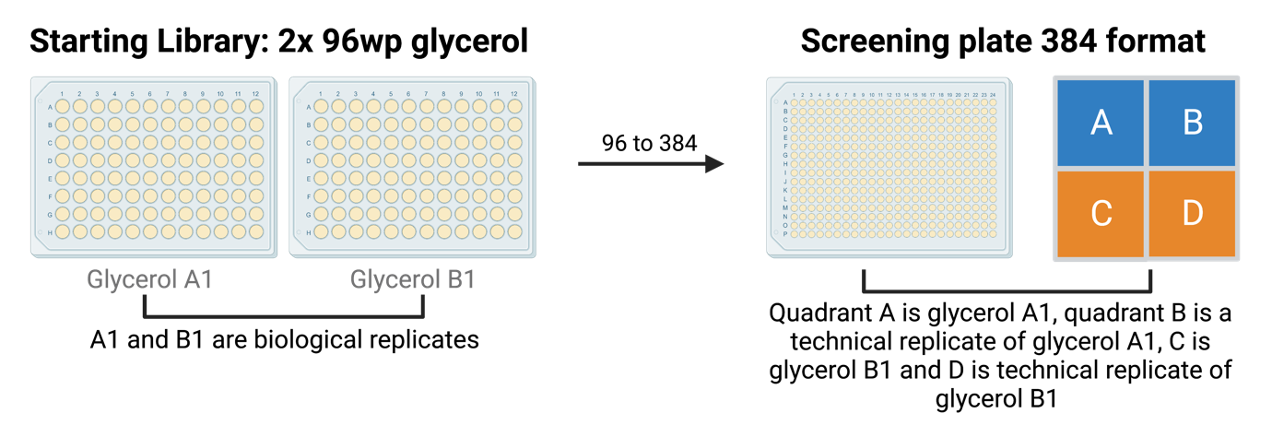

Analysis notes:

- This is a library of blockers: similar to Toxblock we need to use GFP normalisation and not Z-scores
- In the paper (as below) we first normalise by the mean of GFP controls (opacity gene x/mean of GFP controls), then we calculate the ratio between the normalised fitness in ArabinoseIPTG/ normalised fitness in Arabinose
- Compared to our Tactic pipeline, few differences:
  - Its 384 not 1536!
  - The gfp ratio is basically what we do for Toxblock (not z-score)
  - In the paper we compared AraIPTG vs Ara, normally we do AraIPTG vs IPTG

How we did before the data analysis on the paper:

TIC data analysis

Bacterial colony opacity for each strain was quantified using the image analysis tool Iris (Kritikos et al, 2017), and used as a proxy for bacterial fitness. To increase background contrast for colony detection by Iris, plate images were converted to grayscale and contrast enhanced by a value of 12 on Adobe Photoshop 2023 (v.24.7.0). Colonies with opacity equal to 0 were considered pinning misses and were removed. As previously reported (Baryshnikova et al, 2010), colonies on the outermost plate edge had systematically higher opacity values, which were multiplicatively corrected to the median opacity of the rest of the plate. To determine the effect of each blocker in each condition as compared to non-blocking GFP controls and to compare between same-condition plates, the colony opacity of each blocker-carrying strain was divided per plate by the mean opacity of the GFP-carrying controls (n = 32), deriving normalised fitness values for each blocker (n = 12), which were then averaged across the two technical replicates. Each blocker’s effect was then quantified as the ratio between fitness values upon toxin and blocker induction (double-induction plates with arabinose and IPTG) and upon toxin-only induction (arabinose only). Significance was assessed through a two-sided Welch’s t-test comparing the effect of each blocker (n = 6) and GFP (n = 16). A cumulative effect size was derived for each blocker as the mean of its effect divided by the effect of GFP, distinguishing blockers from non-blockers, i.e. neutral (effect size = 1) or aggravating the toxin effect (effect size < 1). Leaky blockers were defined as fitness upon toxin-only expression higher than two standard deviations from the mean of GFP controls in the same condition. Toxic blockers were defined as fitness upon blocker-only expression lower than two standard deviations of GFP controls in the same condition. Hits fulfilled a significance cutoff (p-value < 0.01) and an effect size cutoff of 1.1 for RcaT-Sen2 (1.3 for RcaT-Eco9). Data analysis was implemented with R v.4.3.1 (R Core Team, 2020) and RStudio v. 2023.06.1 + 524 (Posit Team, 2023). Normalized opacity measurements can be found in Appendix Fig. S6.

